**LỊCH SỬ PUSH CODE NHÓM 8**

27/11/2022

11:40

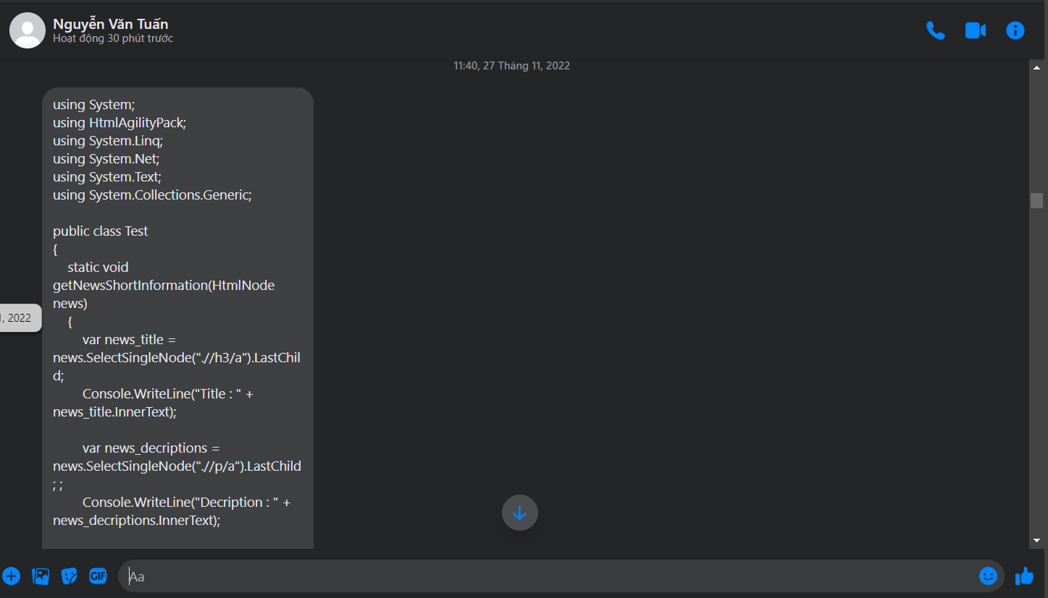

27/11/2022

14:25

28/11/2022

20:30

4/12/2022

11:27

4/12/2022

12:54

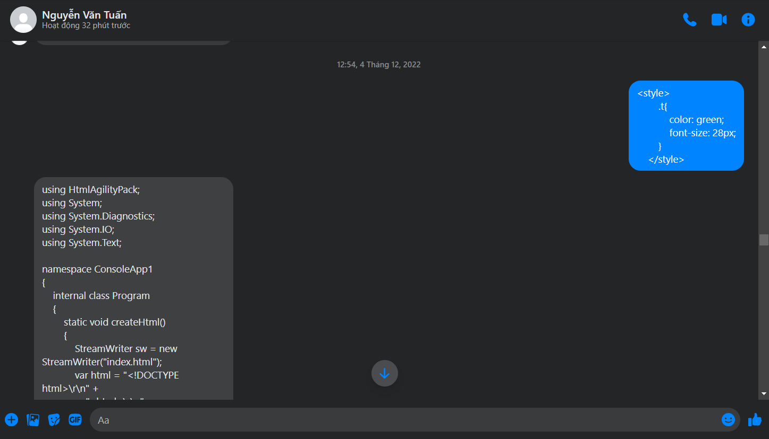

4/12/2022

13:28

5/12/2022

15:50

17/12/2022

9:55

